# Web Technologies | Final project

1. Team members: Guldana Abeshova, Kantemir Maikenov, Nurmukhammed Mugal
2. Our project is a travel agency website designed for people who want to embark on journeys. We offer a range of vacation packages for users to choose from based on their preferences. The website consists of three pages: Home Page, Destination Page, and Book Page. On the Home Page, users will find a brief overview of our site, a gallery showcasing captivating images, and information about our team members. The Destination Page features individual vacation packages where users can click on a destination to view the services we offer along with pricing. Additionally, we will incorporate a customizable booking system similar to a cart on the Book Page, where users can add or remove services according to their preferences. We provide users with options such as Adventures, Food & Drinks, Affordable Hotels, and 24/7 Services. Our aim is to create a user-friendly platform that inspires travelers and allows them to plan their dream trips with ease.
3. Handy list of places to go
4. The ability to customize the itinerary
5. Flexible user interface
6. 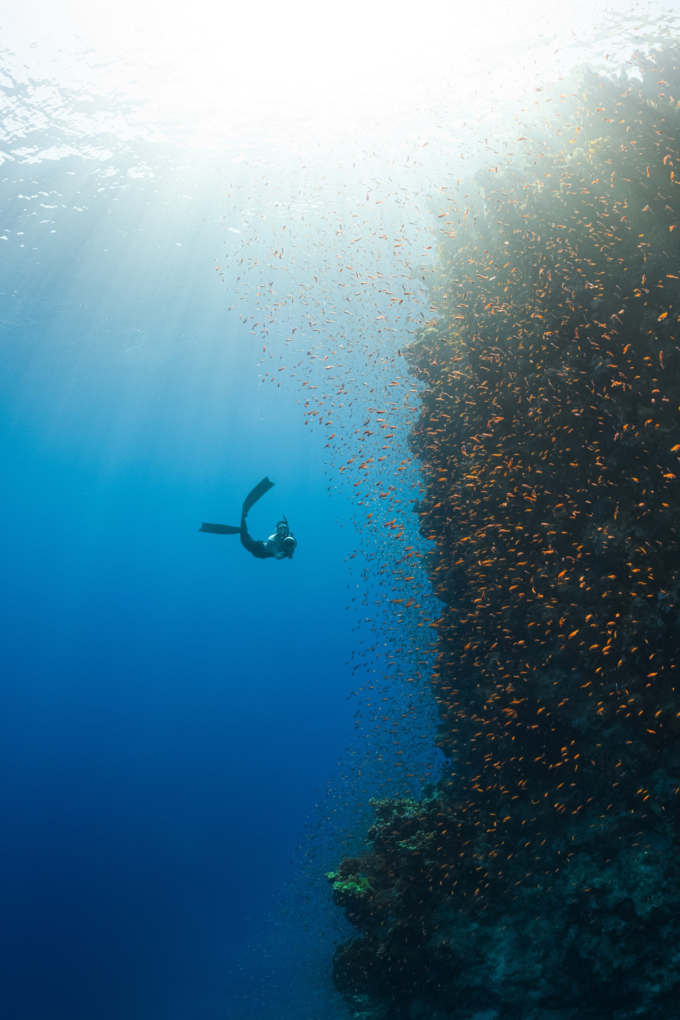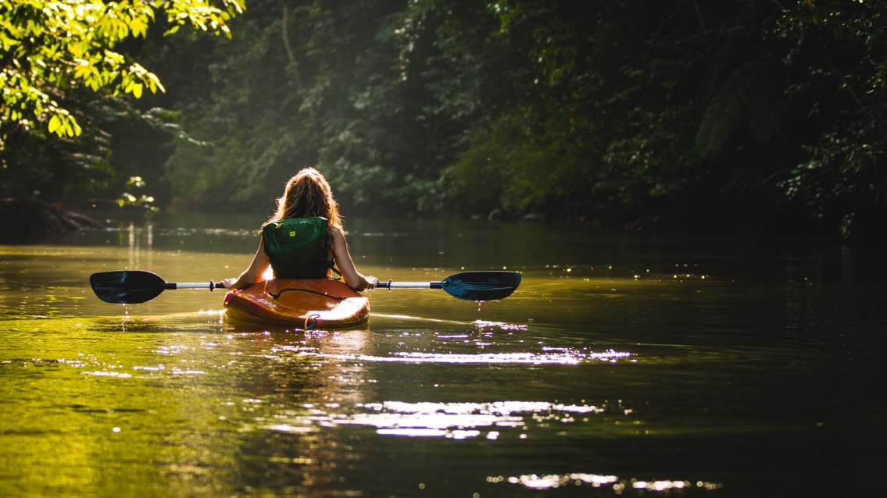

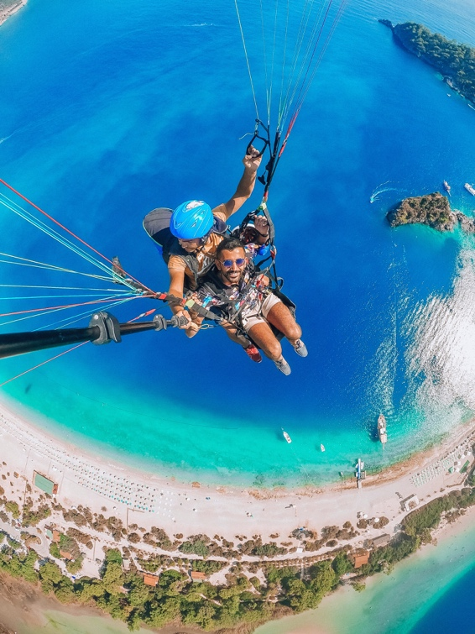

1. Brand name: Aloha Travel



1. We chose the colors Navy (#0E2954),Teal (#2E8A99) and White (#F5F5F5) because they are perfect for creating a calming and trusting atmosphere on our website. These colors are associated with the depth of the sea and endless skies, which evokes a feeling of peace, stability and reliability.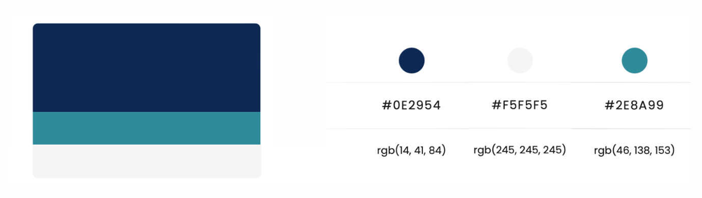
2. Poppins, Wix Madefor Display
3. 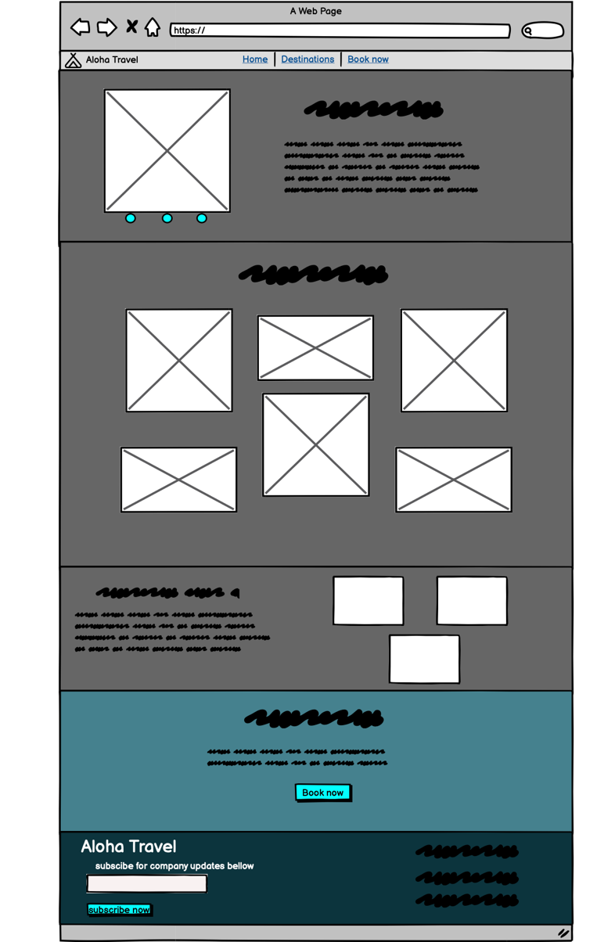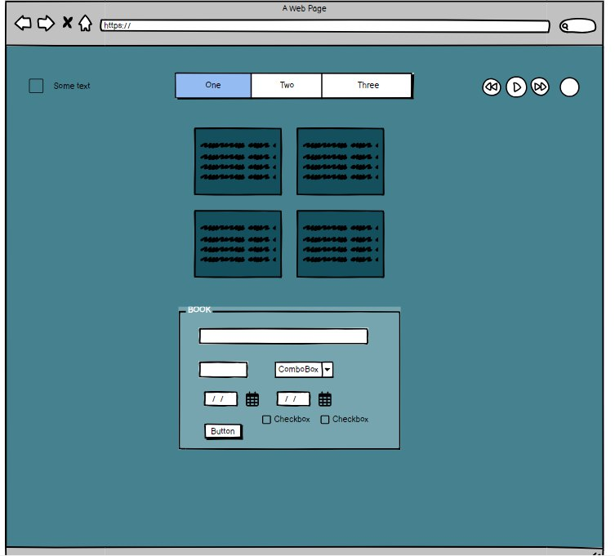
4. Guldana:

a. Html – Home Page

b. CSS – Shared pages (Same design across all pages)

c. JS – Animations of Home Page

Nurmukhamed:

d. Html – Destinations Page

e. CSS – Destinations Page

f. JS – Destinations Page

Kantemir:

g. Html – Book Page

h. CSS – Book Page

i. JS – Book Page

10. https://kantikkk.github.io/WebFinal_Travel_Agency/